**SELECTING YOUR SITE**

TEMPLATE: Please copy content/questions to your own document.

Go to File → Make a Copy → Save to your own Drive.

Your name(s):

**OVERVIEW**

In this assignment, you will be grouped into teams and complete the following tasks:

* Select your Germany Site(s)
* [Familiarize with the EPA and EU (Germany) Guidelines](https://docs.google.com/document/u/1/d/1HBqwCj9kH0OuOwvh_mCzj4XGi9c4O-wvYpCX8pH5IjI/edit)
* Read a Case Study and Answer Corresponding Questions
* Research your Germany Site

**LOOKING AHEAD: FINAL PROJECT!**

Before you start, please read through the Final Project description [here](https://docs.google.com/document/d/1QX_gpWQuGJXWLm7yVFzP1zTSV-IhhIljz-9ScFlnFOs/edit?usp=sharing). Familiarize yourself with the requirements and think about which project type excites you the most.

**SELECTING YOUR GERMANY SITE(S)**

Split into teams of 2-3 and sign up for a Germany site that your team would like to study.

Each city (except for Location 8, which is a rural site) has a population > 500,000 and represents a different geographic region of Germany (besides Cologne and Düsseldorf, which are in the same region).

Sign up sheet: <https://docs.google.com/spreadsheets/d/1txaxo8StpX_n0QTRNhHJ8QR20jK8qmzVN2EuBAdN3nQ/edit?usp=sharing>

While choosing a site, also think and discuss potential research questions or interests you have related to air quality monitoring and its impacts on society. Why are they important? How can such studies help engineers, policy makers, citizens, researchers, or other audiences? Potential ideas to get you thinking:

* Impacts of industry over the years
* Comparisons between pre and current pandemic air quality measurements
* Effects of ecological or industrial policies on air quality
* Comparisons of two nearby sites within a city location
* Comparisons of two urban/rural/suburban/traffic sites within a city location
* Uses of Best Available Control Technology (BACT) in that country or that you are interested in
* Comparisons between EPA and EU guidelines
* See Final Project description for more defined ideas and requirements

NOTE: If your team would like to sign up for two data sites, you **must** check with the professor first.

(Slide 4) List the team members' names here and the site(s) you have chosen.

**EPA AND EU (GERMANY) GUIDELINES**

Familiarize yourself with the United States and Germany air quality standards.

**United States - EPA Air Quality Regulations**

<https://www.epa.gov/regulatory-information-topic/regulatory-and-guidance-information-topic-air#criteriapollutants>

EPA guidelines under the “Air” topic. The Clean Air Act Requires the EPA to designate levels for the six criteria pollutants:

* CO <https://www.epa.gov/naaqs/carbon-monoxide-co-air-quality-standards>
* PM <https://www.epa.gov/naaqs/particulate-matter-pm-air-quality-standards>
* NO2 <https://www.epa.gov/naaqs/nitrogen-dioxide-no2-primary-air-quality-standards>
* Pb <https://www.epa.gov/naaqs/lead-pb-air-quality-standards>
* O3 <https://www.epa.gov/naaqs/ozone-o3-air-quality-standards>
* SO2 <https://www.epa.gov/naaqs/sulfur-dioxide-so2-primary-air-quality-standards>

See also Toxic or Hazardous pollutants (Hg, etc.)

* <https://www.epa.gov/stationary-sources-air-pollution/national-emission-standards-hazardous-air-pollutants-neshap-9>

(Slide 5) Summarize your findings, especially note down information that you may think is important to know when studying your site and analyzing the air quality data from there. While your site is not in the USA, you can imagine if it was so.

**Germany - EEA Air Quality Regulations**

The European Environment Agency is one body that establishes regulations for air quality in Europe. Germany is a member. Their standards can be found in the chart linked here: <https://www.eea.europa.eu/themes/air/air-quality-concentrations/air-quality-standards>

Their list of primary pollutants is different from the EPA list <https://www.eea.europa.eu/themes/air/air-pollution-sources-1>

* BC (Black Carbon)
* CH4 (Methane)
* PM
* SO2
* NOx
* NO2
* NH3
* CO

(Slide 6) Again, summarize your findings, especially note down information that you may think is important to know when studying your site and analyzing the air quality data from there.

**CASE STUDY: POLLUTANT SOURCES AND SPREADS**

Study the following two figures.

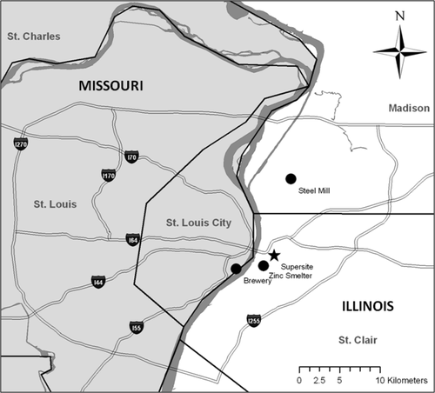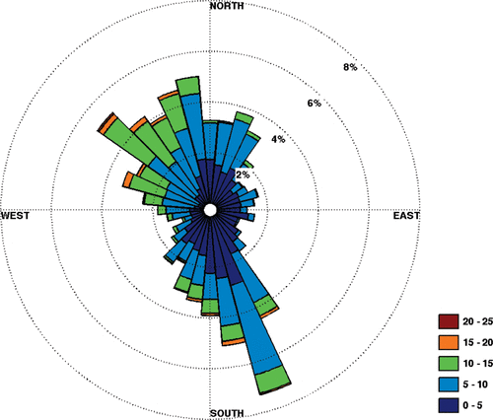

Left Figure: Location of the East St. Louis monitoring site and local sources of SO2.

Right Figure: ​​Wind rose at E. St. Louis for nine winter months from 2003 to 2005. Units in the legend are km/h.

Answer the following questions:

1. Given the map of St. Louis with the marked pollutant sources (brewery, zinc smither, steel mill) and the corresponding windrose plot (which shows the counts of wind speeds grouped by wind direction), what questions do you have about the potential SO2 dispersions in the area?
2. What do you hypothesize or predict about the SO2 dispersion given the two figures?

Now, read the article [“Source Region Identification Using Kernel Smoothing”](https://pubs.acs.org/doi/full/10.1021/es8011723) (by Ronald Henry, Gary A. Norris, Ram Vedantham, and Jay R. Turner) where the figures derive from. You may skip the following sections: Nonparametric Wind Regression Methodology, Uncertainty Estimates,

Answer the following questions:

1. Describe the site of focus.
2. Describe the pollutant that the authors focused on, including how and when were they sampled?
3. Why was this pollutant the focus of the study? Give your best reasoning/guess based on the context of the paper, your own knowledge of air quality, and external sources.
4. Given the data, analysis, and plots in the article, what was the conclusion made by the authors? Which figure do you believe best supports/answers the question(s) made by the authors? Do you find this figure substantial? Do you wish for more data or analysis?
5. Do you have more questions about the analysis or site? What would you do (if you deemed appropriate) to improve the analysis in this paper?
6. Were your pre-reading hypothesis/predictions correct? If yes, which figure(s) in the article do you believe best answers or supports your pre-reading hypothesis? Or, if not, what would be your new hypothesis and supporting figure?

**RESEARCH YOUR SITE**

In preparation for the Final Project, do some research on major sources of your pollutant(s) in the vicinity of your sampling location. Consider major roadways that are nearby and research traffic loads on those roads as potential sources. Keep predominant winds in mind as you're choosing sources - relevant sources will be upwind of your site when pollution is bad (*this will be easier to do after some R openair package tutorials)*.

As you're working, assemble a "major source" table or list, recording things like:

* Pollutant emitted
* Source type (factory, refinery, etc.)
* Location (lat/long or address)
* Emission rate (typically Tons per year)

Write down your recordings here in list or table form. Include at least 3 sources below for your answer sheet submission to Canvas

**SUPPLEMENTARY RESOURCES**

* Wikipedia: Air pollution in Germany
  + <https://en.wikipedia.org/wiki/Air_pollution_in_Germany>
* European Environment Agency: Germany – Air pollution country fact sheet
  + <https://www.eea.europa.eu/themes/air/country-fact-sheets/2021-country-fact-sheets/germany>
* Breeze Technologies (German): How has air quality in Germany changed in the last 40 years?
  + <https://www.breeze-technologies.de/blog/how-has-air-quality-in-germany-changed-in-the-last-40-years/>
* OECD: Germany – Progress in the net zero transition
  + <https://www.oecd.org/regional/RO2021%20Germany.pdf>
* Nature: Scientific Data: APExpose_DE, an air quality exposure dataset for Germany 2010-2019
  + ​​<https://www.nature.com/articles/s41597-021-01068-6.pdf>
* Air Quality Monitoring and Data Management in Germany – Status Quo and Suggestions for Improvement
  + <https://www.researchgate.net/publication/345095191_AIR_QUALITY_MONITORING_AND_DATA_MANAGEMENT_IN_GERMANY_-_STATUS_QUO_AND_SUGGESTIONS_FOR_IMPROVEMENT>
  + What kind of tools could help to support planners and administrative decision makers most in their efforts to improve air quality in cities and regions?
  + What information is necessary for local and regional decisions on appropriate short- and long-term measures?
  + How can available official measurements be used in the best possible way and how can combinations with traffic, satellite, or land-use data improve their validity?
  + What are the capabilities of an AI-based data analytics approach to forecast air pollution on the short-term and to simulate long-term air quality scenarios?
* Future Trends in Ambient Air Pollution and Climate in Germany – Implications for the Indoor Environment
  + <https://www.sciencedirect.com/science/article/pii/S036013231830458X>